Pheromone trail following in the ant Lasius niger: high accuracy and variability but no effect of task state

TOMER J. CZACZKES^{1,5}, MARTIN CASTORENA^{1,2}, ROGER SCHÜRCH^{3,4} and JÜRGEN HEINZE¹

¹ Institute of Zoology, Universität Regensburg, Universitätsstraße 31, D-93053 Regensburg, Germany, ² Department of Ecology & Evolutionary Biology, University of Colorado at Boulder, Colorado, U.S.A., ³ CTU Bern, Department of Clinical Research, University of Bern, Bern, Switzerland, ⁴ Institute of Social and Preventive Medicine (ISPM), University of Bern, Bern, Switzerland and ⁵Biologie I, Universität Regensburg, Universitätsstraße 31, 93053 Regensburg, Germany.

Short title: Trail following in the ant Lasius niger

Correspondence: Tomer J. Czaczkes, Biologie I, Universität Regensburg, Universitätsstraße 31, 93053 Regensburg, Germany. Tel: +49 941 943 2996; e-mail: tomer.czaczkes@biologie.uni-regensburg.de

Abstract
The use of pheromone trails in ant colony organisation is an important model for understanding collective decision-making and complex adaptive systems. The ant Lasius niger L. (Hymenoptera: Fomicidae) is one of the main model organisms used for such studies. Key to understanding pheromone trail use by ants is knowing how well trails are followed. A previous report suggested that L. niger trail following is poor, with between 60-70% accuracy at a T-bifurcation. It is hypothesised that the true trail following accuracy was higher, and that the low accuracy previously reported was due to a methodological error. Specifically, it is hypothesised that ‘task state’ – what the ants ‘thought they were doing’ – affected pheromone following accuracy. Here, the task state of the ants is set experimentally to one of three states: scouting (completely naive), recruited (having information that food has been found, but not where it is) and shuttling (having a strong memory of the location of a food source). Trail following accuracy was tested for each group. Trail following is found to be more accurate than previously reported; 83%, 82% & 74% correct decisions for scouts, recruits, and shuttlers, respectively. However, the difference between the three groups was not significant. Importantly, very high inter-trial variation is reported both in the current experiment and in experiments from other research groups. This variation is unexplainable by trail strengths or colony-level differences, and is highlighted as an important factor when experimentally measuring trail following.

Key words: Pheromone trails, motivation, private information, social information, ants, behavioural methods, behavioural states, unexplained variation

Introduction
Collective decision-making in social insects is a major model system for understanding complex adaptive systems and group decision making (Couzin, 2009; Czaczkes et al., 2015a). Many of the insights into collective organisation derived from social insects arose from the study of pheromone trail use in ants (Bonabeau et al., 2000; Czaczkes et al., 2015a). For example, the famous Ant Colony Optimization metaheuristic (Dorigo & Di Caro, 1999; Dorigo & Stützle, 2004) is inspired by the deposition and evaporation of ant pheromone trails (Beckers et al., 1990; Goss et al., 1989).

Basic to our understanding of how pheromone trails influence collective behaviour is to know how they are followed. Thus, a key bioassay is the use of Y and T mazes to test pheromone trail following. A pheromone trail is deposited on one arm of the maze, a colony is then given access to the maze, and the proportion of ants following the marked path is recorded (e.g. Hangartner, 1969; Horstmann, 1976; Aron et al., 1993; Witte et al., 2007; Grüter et al., 2011; von Thienen et al., 2014).

The black garden ant, Lasius niger, is an important model organism for studying collective behaviour. The individual foragers are big enough to be easily marked and followed, and yet the colonies are large, and rely on mass recruitment by pheromone trails. This allows the easy study of how individual decisions influence collective behaviour (Beckers et al., 1990; Czaczkes et al., 2015c; Dussutour et al., 2004; Grüter et al., 2012). The pheromone trail following accuracy of L. niger was tested in a T maze by Grüter et al. (2011), and found to be relatively low: 62, 65, or 70% of ants followed the arm of the T maze marked by 1, 5, or 20 trail laying ants, respectively. This is somewhat similar to the results found for other mass recruiting species using naturally-deposited trails, such as Pharaoh’s ants Monomorium pharaonis (70 or 80% on plastic and paper substrates marked by c. 1200 ant passages, respectively, Jeanson et al., 2003) or Formica rufa (70% correct decisions after 5 trail laying passages, 86% correct decisions after c. 300 ant passages, Horstmann, 1976).

However, the trail following accuracy reported for L. niger by Grüter et al. (2011) is much lower than accuracies of Pheidole oxyops or Paratrechnia longicornis, which were measured on an identical maze to the Grüter et al. study, but using a trail deposited by only one ant (Czaczkes & Ratnieks, 2012; Czaczkes et al., 2013b). It has been argued that the poor pheromone following abilities of L. niger are due to its’ strong reliance on visual orientation and the diffuse and semi-permanent nature of their main food source, aphid colonies (Czaczkes et al., 2015a; Grüter et al., 2011).

We began to suspect that trail following accuracy by L. niger is in fact much higher than reported. Anecdotal evidence from open-arena experiments suggested that naturally-deposited trails could be very accurately followed (see Fig. 1, image from Czaczkes et al., 2016). Additionally, somewhat buried amidst other results, Czaczkes et al. (2013a) reported that naive L. niger workers made 85% and 84% correct decisions on the first and second bifurcation of a complex maze when walking on trails marked by c. 35 ant passages. This is in line with the highest trail following accuracy (c.83%) reported for L. niger by von Thienen et al. (2014), although we note that this result was for a very strong, artificially deposited trail. Thus, higher trail following accuracies than those given by Grüter et al. (2011) have been reported.

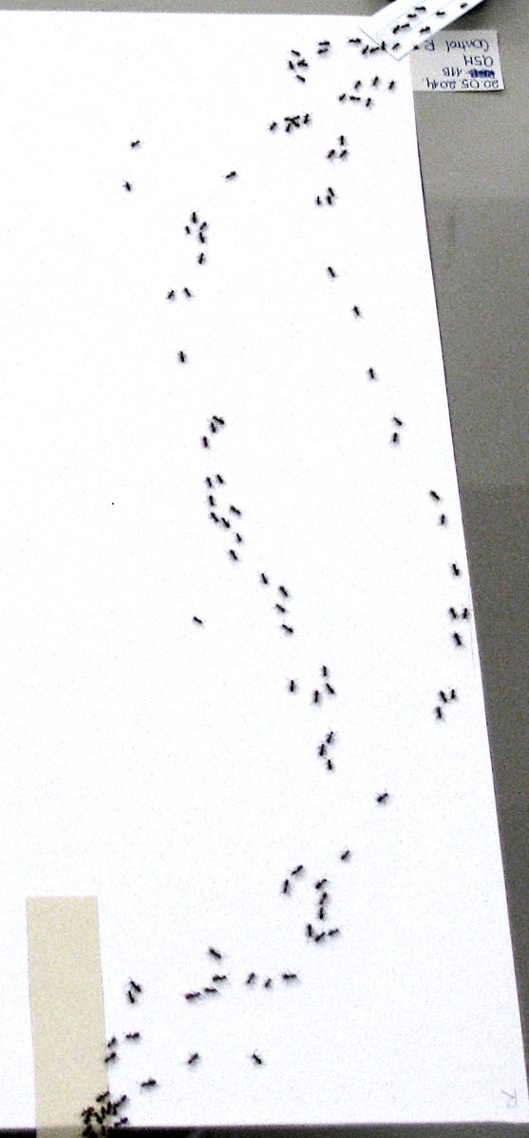
What might explain these conflicting results? One possible explanation is that the ‘task state’ of the ants differed between experiments. By task state the specific role the ant is currently performing – what it ‘thinks’ it is doing – is meant. For example, if an ant has just sensed alarm pheromone and damage to its nest and is running back and forth with gaping mandibles, it is likely in an “alarm/defence” task state,. It is thus unlikely to respond to stimuli such as recruitment to a food source. In Grüter et al. (2011) the pheromone trails were laid by the same ants which were later tested. The ants were prevented from gaining directional information by placing the food source in the middle of the T maze. However, the ants that fed at the feeder very likely learned the location of the food source, and were making a return visit to the food source when they were tested. These ants might then have been in a “shuttling” task state. In the same experiment, Grüter et al. (2011) showed that when memories and trail pheromones conflict, memories are overwhelmingly followed. Thus, perhaps when pheromone following was tested, ants that had previously been at the central feeder arrived at the remembered food location, could not find it, and began a random search, making 50% correct choices by chance. Ants which had not been to the food source might have been in a different task state: they might have been scouting or have received recruitment signals from the ants, which had found the food. The trail following accuracy reported might thus be a combination of the results from the non-naive ants, which may have been ignoring pheromone information, and naive ants which may have been following pheromones. Due to methodological differences between Czaczkes et al. (2013a) and Grüter et al. (2011), tested ants in Czaczkes et al. had good social information that food was present, but no direct experience with the food. It is thus hypothesised here that these two experiments tested ants in two different ‘task states’ – recruited ants (naive ants with information that food is available), and shuttling ants (ants which are busy making return visits to a known food source). It is further hypothesised that these recruits would show higher accuracy than shuttlers. This is reasonable, as it has long been known that in many ants and termites the pheromone trails act only as orientation signals, and require a separate recruitment signal, either mechanical or chemical, for following to begin (Cammaerts-Tricot, 1974; Hölldobler, 1971; Traniello, 1977, 1982). However, in the only other explicit test of ‘priming’ (=changing the task state of ants) for trail following by food provision of which the authors are aware, Horstmann (1976) reports no effect of priming on trail following accuracy in Formica rufa.

Fig. 1. A Lasius niger foraging trail. Still image from a separate experiment. See Czaczkes et al. (2016) for details.

Here, the effect of three different ‘task states’ which foraging L. niger might be in; scouting, recruited, and shuttling, is tested for its effect on trail follow. It is hypothesised that pheromone following strength would be recruited > scouting > shuttling.

Methods

Study species, housing, and maintenance
We used eight colony fragments of the black garden ant, Lasius niger (L.), collected in 2015 from eight different colonies on the University of Regensburg campus. Colony fragments were queenless with 500 – 1000 workers and small amounts of worker-produced brood, with roughly the same amount of brood in all fragments. Each colony fragment was further split into two equal fragments. One fragment of each colony was used to deposit a natural pheromone trail (henceforth the donor fragment), which was used to test trail following accuracy by the other fragment (henceforth the test fragment). Each fragment was housed separately in a plastic box (40×30×20cm) with a layer of plaster on the bottom. Each box contained a circular plaster nest (14cm diameter, 2 cm high). The ants were fed three times per week with Bhatkar diet, a mixture of egg, agar, honey and vitamins (Bhatkar & Whitcomb, 1970), and supplemented with Drosophila melanogaster fruitflies. Both fragments were deprived of food for four days prior to each trial to give high and consistent motivation for foraging and pheromone deposition. Water was provided ad libitum.

Experimental design
The aim of this series of experiments was to test whether the task state of the ant - the current task the ant ‘thinks’ it is carrying out - affects pheromone trail following accuracy.

(i) Pheromone trail collection
We used naturally deposited pheromone trails to test trail following, as synthetic blends may miss out important secondary trail components, and gland-extracts may not be of a realistic strength.
A plastic T maze with a 2 cm wide stem, and a 2x22 cm head was used in these experiments (fig. 2). This maze was identical to that used by Grüter et al. (2011). The maze was covered with replaceable printer paper overlays. A thin acetate sheet (1.5 x 1.5 cm) was placed on one end of the T maze head, and a drop of 1.5 molar sucrose solution was placed on top. This acted as a feeder. The first 5 cm of the arm without the feeder was covered in an additional paper overlay (figure 2). This could later be discarded, to ensure that there was no pheromone on the arm of the maze heading away from the feeder.

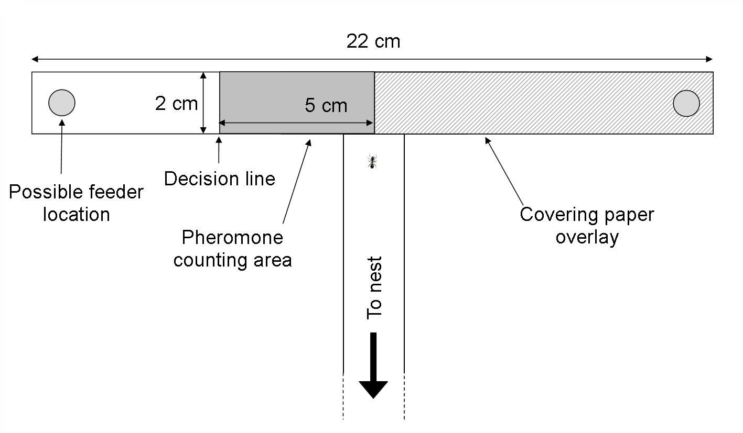

Fig. 2. The T maze setup, used to study pheromone trail following accuracy. A pheromone trail is formed by allowing a Lasius niger colony fragment to forage at a feeder on one arm of the maze. The other arm of the maze is covered by a disposable overlay to ensure no pheromone is deposited on it. When the pheromone trail is laid, the overlay is discarded and the maze connected to a different colony fragment. The number of ants crossing each decision line is noted. The ant on the T maze stem is shown roughly to scale.

The donor fragment was connected to the T maze via a drawbridge mechanism (also covered in printer paper), and ants were allowed to enter the maze, find the feeder, and begin feeding and recruiting. The number of pheromone depositions, and the number of ants depositing pheromone, was then counted for 20 minutes. Pheromone deposition is a clear and stereotyped behaviour in Lasius niger, and easily quantified by eye (Beckers et al., 1992; Czaczkes & Heinze, 2015). A single L. niger pheromone dot has been calculated to decay in c. 47 minutes (Beckers et al., 1993). The average number of depositions made per trial was 18.7, SD 5.0. The average number of trailing ants (ants performing at least one pheromone deposition) was 13.1, SD 5.0. After 20 minutes of pheromone collection the bridge was raised, the ants on the maze were gently returned to the colony, the paper overlay covering the non-feeder arm was discarded, and the entire maze was placed in a clean pre-cooled plastic box, and stored for at -20° C. This allowed time to set the task state of the ants, which were to be tested for pheromone following. We then carried out one of three behavioural test treatments, depending on the task state to be tested.

(ii) Treatment 1 - ‘scouting’ task state treatment
This treatment was designed to set the tested ants to a ‘scouting’ task state, where the ants are hungry, but have no information that a new food source is available. The maze was allowed to remain in the -20° C freezer for 30 minutes (for consistency with treatment 2, see below), and then replaced in its original position, and allowed to warm up for 3 minutes. The drawbridge was then used to connect the test fragment (from the same original colony as the donor fragment) to the T maze. Ants were allowed to run onto the maze, and their behaviours video recorded in high definition (Sony Handycam CX190) from above. Ants crossing a decision line printed 5cm from the centre of the T maze (Fig. 2) were brushed off the bridge into a Fluon-coated container. Data collection continued for 10 minutes. All the ants were then returned to the test fragment. The number of ants crossing each decision line was later scored from the videos. All pheromone overlays were replaced after every test, and the T maze cleaned with ethanol.

(iii) Treatment 2 - ‘shuttling’ and ‘recruited’ task states treatment
This treatment was designed to set the tested ants to one of two states; ‘shuttling’ ants and ‘recruited’ ants. Shuttling ants are ants which have a strong memory of a current food source, and are making repeated return visits to this food source, most likely using their private route memories rather than trail pheromones (Grüter et al., 2011). These ants may also be in the process of recruiting other ants by depositing trail pheromones. Recruited ants are ants which have no current direct knowledge of a food source, but have received information from a ‘shuttling’ ant that a food source is present.
After a pheromone trail was collected and stored at -20 C° as above, a second T maze identical to the first, but covered in fresh paper overlays, was connected to the test fragment, and a sucrose feeder was placed at the centre of the T maze head. This allowed ants finding it to learn that a food source was present, without learning a preference for one side of the T maze (as in Grüter et al., 2011). The first six ants to reach the feeder were individually marked with dots of acrylic paint on their abdomen, and all remaining ants were removed from the maze and replaced in the test fragment. The marked ants were then allowed to make 4 – 6 return trips to the feeder, keeping the group average at 5 trips. No other ants were allowed on the apparatus during this time. During these return trips, the marked ants deposited pheromone in the nest box, and performed jerking recruitment behaviours in the nest and nest box. L. niger form simple route memories very rapidly, and would certainly learn the location of the food source after 5 visits (Grüter et al., 2011; Czaczkes et al., 2015b). These ants are considered to be in the ‘shutting’ task state. ‘Recruited’ ants are ants which have no personal information about the location of currently available food, but have likely experienced recruitment by ‘shuttling’ ants inside the nest or nest box, and so have some information that there is currently a food source to be found.
After the training and recruitment portion of the experiment, the training maze was replaced with the pheromone-marked maze stored at -20° C freezer, which was allowed to warm up for three minutes. The test fragment was then connected to the maze, and data collection proceeded as in the ‘scouting’ treatment. In this treatment, however, we specifically noted by eye the decisions of the marked ants. The marked ants were considered ‘shuttling’ and the unmarked ants were considered ‘recruited’.

(iv) Treatment 3 - Increasing the ‘shuttling’ task state sample size
To bolster the sample size of the ‘shuttling’ ants’ treatment, five of the colonies underwent a further experiment. This experiment was identical to treatment 2 above, except that in addition to the six individually marked ants, a seventh colour was used to mark an additional 10 – 15 ants. All marked ants were allowed to make repeated visits until the individually coloured ants had made on average 5 visits to the feeder. Testing then proceeded as in treatment 2, with all marked ants considered to be in the ‘shuttling’ task state.

Each colony was tested twice in treatments 1 and 2, with the feeder once on the left and once on the right. Each colony was only tested once in treatment 3, with half the colonies tested to the right, and half to the left. Unfortunately, two instances of treatment 2 were accidentally performed with 1 M sucrose. These data were excluded from the analysis.

Statistical analysis
In order to ensure an unbiased analysis, the initial data analysis was carried out ‘blind’ (MacCoun & Perlmutter, 2015). The data was first anonymised by renaming all variables with uninformative names. The anonymised data were then sent for analysis to RS, who had no prior knowledge of the experimental design or hypotheses. Once the non-significant effect of our main treatment was described, RS was informed of the experimental design, and a detailed, unblinded post-hoc analysis of other patterns in the data was carried out. A detailed analysis workflow of the blind statistical analysis, including blind analysis instructions to RS, is presented in Online Supplement 1. An analysis workflow for the informed statistical analysis is presented in Online Supplement 2. The complete anonymised and de-anonymised datasets are presented in Online Supplement 3.

Statistical analysis was carried out in R 3.0.3 (R Core Team, 2012). The effect of motivational state on trail following accuracy was investigated using binomial mixed effect models to account for colony and experiment random intercepts. These mixed effect models were calculated using the lme4 package (version 1.1-6) (Bates et al., 2015). Pheromone depositions, the time pheromone trails were stored in the freezer, and the time pheromone trails were stored out of the freezer were scaled. First, we calculated odds ratios (OR) using a simple model with no adjustments. We then calculated the results from a fully adjusted model correcting for all potential confounding variables simultaneously. We present OR and 95% confidence intervals (CI) for how task state affects trail following accuracy. In a further exploratory analysis, we used simple models to investigate how the other variables affected trail following accuracy. The intra-class correlation among trials and colonies were calculated from the models random effects using the method of Wu et al. (2012).

Results

While the mean trail following accuracy of recruited ants (accuracy 83%, OR 0.9, CI 0.7 - 0.9 ) was very slightly higher than that of scouting ants (accuracy 82%, OR 0.8 CI, 0.7 - 0.9, OR recruited vs. scouting: 1.2, CI 0.6 - 2.3), and shuttling ants were on average less accurate than scouting and recruited ants (accuracy 74%, OR 0.8, CI 0.6 - 0.9; OR shuttling vs. scouting: 0.7, CI 0.3 - 1.4), these differences were not significant both before (LTR: χ2 = 2.1 , df = 2 , P = 0.35 ; see figure 3) and after adjusting for potential confounding variables (OR recruited: 1.2, CI 0.6 - 2.2; OR shuttling: 0.7, CI 0.3 - 1.4); LTR: χ2 = 1.9 , df = 2 , P = 0.38 ).

There is no evidence that the confounding variables had any influence on the accuracy of correctly following the trail (table 1). Surprisingly, while the number of pheromone depositions had a marginally significant influence on trail following accuracy (table 1, Fig. 4), this result is merely descriptive, and the prediction interval of this variable remains very wide.
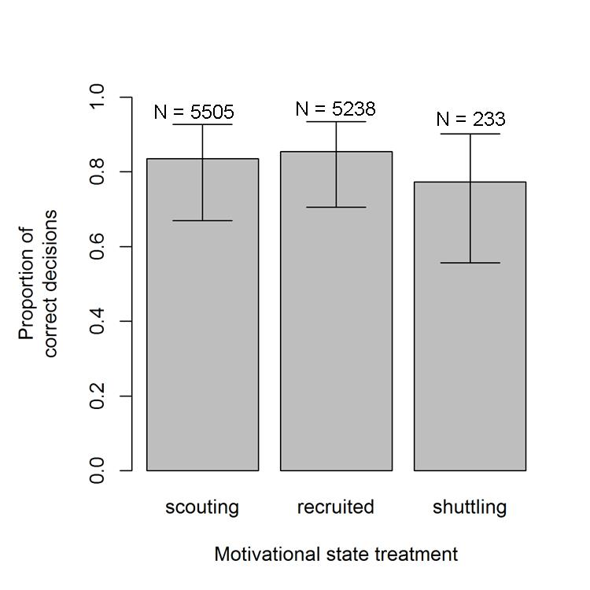

Fig. 3. Trail following accuracy of Lasius niger on a T maze, depending on their task state. There are no significant differences among groups. The population predictions (bars) and their 95% confidence intervals are shown, as well as the sample size (individual ants) of each group. The dashed line indicates the expected accuracy under the assumption of random choice.

The unaccounted variability of trail following accuracy between trials was very high (see Fig. 4). Some trials, in which hundreds of ants were tested, showed almost 100% accuracy, while in other seemingly identical trials accuracy could be as low as 50%, or lower (intra-class correlation coefficient for trials: r = 0.14). Similarly, colonies were not very consistent in trail following accuracy (ICC: r = 0.12).

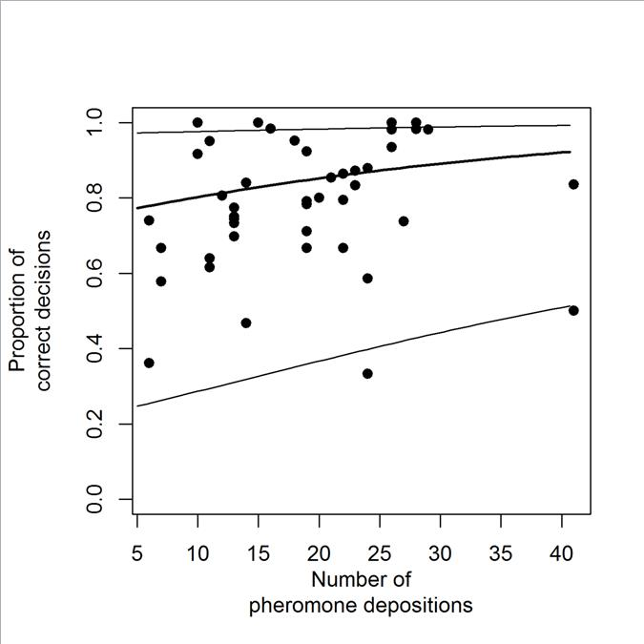

Fig. 4. The trail choice accuracy in Lasius niger is very weakly influenced by the number of pheromone depositions placed constituting the trail. Shown is the prediction of accuracy from a simple model (thick line) and the 95% prediction interval (grey area). The dashed line indicates expected accuracy under the assumption of random choice. Dots are overall accuracy for individual trials.

Discussion
No strong evidence that task state affects trail following accuracy was found. While shuttling ants made fewer correct choices, as hypothesised, their accuracy was not significantly lower than ants in the other two task states. However, the similarity in trail following accuracy of shuttling ants in this experiment and of presumably-shuttling ants in Grüter et al. (2011) (74% vs 62%, 65%, or 70%, for 1, 5 or 20 trail laying ants, respectively) is suggestive.

Detecting differences in following accuracy would be difficult, even with a large sample size, as the range over which such effects play at the collective level is likely to be low. Consider the following scenario: Assume that the true pheromone following accuracy of ants in the right task state is 80% (e.g. Czaczkes & Ratnieks, 2012; Czaczkes et al., 2013a; Czaczkes et al., 2013b). At first glance, this would imply a possible range of 30 percent points (the range between random choice (50%) and 80%) over which to detect a task state effect. However, this assumes that all ants in the wrong task state completely ignore pheromone trails. If, for example, half of the wrong-state ants ignored pheromone information, one would expect half of the ‘ignorers’ to go in the right direction, and half in the wrong direction. So a quarter (25%) of the total ants will make an incorrect decision. Of the ants in the correct state, ‘non-ignorers’, 80% will make a correct decision, and 20% will make an incorrect decision. Thus 10% (80% of the ‘non-ignorer’ ants, which make up 50% of total ants) of the total ant decisions will be incorrect decisions by ‘non-ignorers’. Adding these errors together, one gets 25% + 10% = 35% errors, and thus 65% correct decisions. This leaves only a range of 15% (the range between 65% and 80%) over which to detect any putative effect.

With the above in mind, very large sample sizes were collected where possible, with the aim of overcoming such difficulties. Nonetheless, it is quite possible that the results represent a type II error (a false negative), and that shuttling ants are indeed less likely to follow pheromone trails. However, the strength of this effect at the group level, if real, is small enough not to be easily detectable, and is thus also perhaps not of great biological importance, as it is overshadowed by other sources of variation (see below). Thus, while it is best practice to always ensure that animals in behavioural experiments are in an appropriate task state, our results lend credibility to the many trail following experiments in which task states were not controlled (e.g. Aron et al., 1993; Cammaerts et al., 1994; Campos et al., 2016; Cristaldo et al., 2014; Grüter et al., 2011; Reinhard & Kaib, 2001; Simon & Hefetz, 1991; van Oudenhove et al., 2012; von Thienen et al., 2014; von Thienen et al., 2016; Witte et al., 2007).

A surprising, and perplexing, finding of the experiment was the large inter-trial variation in pheromone following, for which no satisfactory explanation can be found. Some trials, containing hundreds of ants, showed over 95% accuracy. Other, seemingly similar trials, with equally high sample sizes, showed accuracies of 50% or less (see Fig. 4). This pattern cannot be satisfactorily explained by variation in trail strength. Other relevant variables such as room temperature and pheromone decay time (van Oudenhove et al., 2011, 2012), were held stable. While colony sizes were not standardised, colonies showed low interclass correlation, and thus colony identity does not explain a large proportion of the variation in the dataset. Moreover, similar variation to that reported here can be seen in other pheromone-following datasets (Czaczkes & Ratnieks, 2012; Czaczkes et al., 2013b; Grüter et al., 2011; Traniello, 1989; von Thienen et al., 2014; von Thienen et al., 2016), and it is likely that such variation could be found, if looked for, in many other similar datasets. This is an issue well worth investigating further, as the range over which accuracy varies between trials is very large indeed (Fig. 4), and understanding this variation would have large implications for understanding trail-based recruitment. While not knowing the root cause of this variation is somewhat unsatisfying, an important lesson can nonetheless be learned: when studying trail following, a large number of trials, as well as high sample sizes, are crucially important. While the ‘tuned error’ hypothesis has been called into doubt in the context of intra-dance variation in the honeybee waggle dance (Couvillon et al. 2012, Tanner & Visscher, 2005, 2010; Weidenmüller & Seeley, 1999), error in trail following or recruitment may nonetheless play an important role during collective decision making in ants (Deneubourg et al., 1983; Dussutour et al., 2009).

Conclusions
Against expectations, no strong evidence that task state affects trail following in the ant Lasius niger was found. If task state does play a role in trail following accuracy, it is most likely not large. Trail following in L. niger was found to be more accurate than previously reported, reaching c. 82% on a T maze. Trail following accuracy also showed great and unexplained inter-trial variation, and this seems to be a common theme in trail-pheromone following bioassays. Finding the source of this variation is an important future goal in understanding pheromone trail use.

Acknowledgements
Many thanks to Abel Bernadou, Adam Cronin, and an anonymous reviewer for comments on a previous version of this paper. TJC was supported by an Alexander von Humboldt Postdoctoral Researcher grant and a DFG Emmy Noether group leader grant (grant number CZ 237/1-1). MGC was supported by a grant from the CU-Boulder Office of International Education in partnership with the Max Kade Foundation.

References
Aron, S., Beckers, R., Deneubourg, J. & Pasteels, J. M. (1993). Memory and chemical communication the orientation of two mass-recruiting ant species. Insectes Sociaux 40, 369–380.
Bates, D., Mächler, M., Bolker, B. & Walker, S. (2015). Fitting Linear Mixed-Effects Models Using lme4. Journal of Statistical Software, 67, 1-48.
Beckers, R., Deneubourg, J. L., Goss, S. & Pasteels, J. M. (1990). Collective decision making through food recruitment. Insectes Sociaux, 37, 258–267.
Beckers, R., Deneubourg, J. & Goss, S. (1992). Trail laying behaviour during food recruitment in the ant Lasius niger (L.). Insectes Sociaux, 39, 59–71.
Beckers, R., Deneubourg, J. L. & Goss, S. (1993). Modulation of trail laying in the ant Lasius niger (Hymenoptera: Formicidae) and its role in the collective selection of a food source. Journal of Insect Behavior, 6, 751–759.
Bhatkar, A. & Whitcomb, W. H. (1970). Artificial diet for rearing various species of ants. Florida Entomologist, 53, 229–232.
Bonabeau, E., Dorigo, M. & Theraulaz, G. (2000). Inspiration for optimization from social insect behaviour. Nature, 406, 39–42.
Cammaerts, R., Cammaerts, M.-C. & Dejean, A. (1994). The trail of the African urticating ant Tetramorium aculeatum: Source, potency, and workers’ behavior (Hymenoptera: Formicidae). Journal of Insect Behavior, 7, 533–552.
Cammaerts-Tricot, M. C. (1974). Piste et phéromone attractive chez la fourmi Myrmica rubra. Journal of Comparative Physiology A: Neuroethology, Sensory, Neural and Behavioral Physiology, 88, 373–382.
Campos, R. da S., Mendonça, A. de L., Cabral Jr., C. R., Vaníčková, L. & Do Nascimento, R. R. (2016). Chemical and behavioural studies of the trail-following pheromone in the leaf-cutting ant Atta opaciceps, Borgmeier (Hymenoptera: Formicidae). Journal of Insect Physiology, 86, 25–31.
Couvillon, M. J., Phillipps, H. L. F., Schürch, R., & Ratnieks, F. L. W. (2012). Working against gravity: horizontal honeybee waggle runs have greater angular scatter than vertical waggle runs. Biology Letters, rsbl20120182
Couzin, I. D. (2009). Collective cognition in animal groups. Trends in Cognitive Sciences, 13, 36–43.
Cristaldo, P. F., DeSouza, O., Krasulová, J., Jirošová, A., Kutalová, K., Lima, E. R., Šobotník, J. & Sillam-Dussès, D. (2014). Mutual use of trail-following chemical cues by a termite host and its inquiline. PLoS ONE, 9, e85315.
Czaczkes, T. J. & Heinze, J. (2015). Ants adjust their pheromone deposition to a changing environment and their probability of making errors. Proceedings of the Royal Society B-Biological Sciences, 282, 20150679 .
Czaczkes, T. J. & Ratnieks, F. L. W. (2012). Pheromone trails in the Brazilian ant Pheidole oxyops: extreme properties and dual recruitment action. Behavioral Ecology and Sociobiology, 66, 1149–1156.
Czaczkes, T. J., Grüter, C. & Ratnieks, F. L. W. (2013a). Ant foraging on complex trails: route learning and the role of trail pheromones in Lasius niger. Journal of Experimental Biology, 216, 188–197.
Czaczkes, T. J., Vollet-Neto, A. and Ratnieks, F. L. W. (2013b). Prey escorting behavior and possible convergent evolution of foraging recruitment mechanisms in an invasive ant. Behavioral Ecology, 24, 1177–1184.
Czaczkes, T. J., Grüter, C. & Ratnieks, F. L. W. (2015a). Trail pheromones: an integrative view of their role in colony organisation. Annual Review of Entomology, 60, 581–599.
Czaczkes, T. J., Czaczkes, B., Iglhaut, C. & Heinze, J. (2015b). Composite collective decision-making. Proceedings of the Royal Society B-Biological Sciences, 282, 20142723.
Czaczkes, T. J., Franz, S., Witte, V. & Heinze, J. (2015c). Perception of collective path use affects path selection in ants. Animal Behaviour, 99, 15–24.
Czaczkes, T. J., Salmane, A. K., Heinze, J. & Klampfleuthner, F. A. M. (2016). Private information alone can cause trapping of ant colonies in local feeding optima. Journal of Experimental Biology, 219, 744–751.
Deneubourg, J. L., Pasteels, J. M. & Verhaeghe, J. C. (1983). Probabilistic behaviour in ants: A strategy of errors? Journal of Theoretical Biology, 105, 259–271.
Dorigo, M. & Di Caro, G. (1999). Ant colony optimization: a new meta-heuristic. In Proceedings of the 1999 Congress on Evolutionary Computation, p. 1477 Vol. 2. IEEE.
Dorigo, M. & Stützle, T. (2004). Ant Colony Optimization. MIT Press.
Dussutour, A., Fourcassié, V., Helbing, D. & Deneubourg, J.-L. (2004). Optimal traffic organization in ants under crowded conditions. Nature, 428, 70–73.
Dussutour, A., Beekman, M., Nicolis, S. C. & Meyer, B. (2009). Noise improves collective decision-making by ants in dynamic environments. Proceedings of the Royal Society B Biological Sciences, 276, 4353–4361.
Goss, S., Aron, S., Deneubourg, J. L. & Pasteels, J. M. (1989). Self-organized shortcuts in the Argentine ant. Naturwissenschaften 76, 579–581.
Grüter, C., Czaczkes, T. J. & Ratnieks, F. L. W. (2011). Decision making in ant foragers (Lasius niger) facing conflicting private and social information. Behavioral Ecology and Sociobiology, 64, 141–148.
Grüter, C., Schürch, R., Czaczkes, T. J., Taylor, K., Durance, T., Jones, S. M. & Ratnieks, F. L. W. (2012). Negative feedback enables fast and flexible collective decision-making in ants. PLoS ONE 7, e44501.
Hangartner, W. (1969). Orientierung von Lasius fuliginosus Latr. an einer Gabelung der Geruchsspur. Insectes Sociaux, 16, 55–60.
Hölldobler, B. (1971). Recruitment behavior in Camponotus socius (Hym. Formicidae). Journal of Comparative Physiology A: Neuroethology, Sensory, Neural and Behavioral Physiology, 75, 123–142.
Horstmann, K. (1976). Über die Duftspur-Orientierung bei Waldameisen (Formica polyctena Foerster). Insectes Sociaux, 23, 227–242.
Jeanson, R., Ratnieks, F. L. W. & Deneubourg, J. L. (2003). Pheromone trail decay rates on different substrates in the Pharaoh’s ant, Monomorium pharaonis. Physiological Entomology, 28, 192–198.
Kaspari, M. & Vargo, E. L. (1995). Colony size as a buffer against seasonality: Bergmann’s rule in social insects. American Naturalist, 610–632.
MacCoun, R. & Perlmutter, S. (2015). Blind analysis: Hide results to seek the truth. Nature, 526, 187–189.
R Core Team (2012). R: A Language and Environment for Statistical Computing. Vienna, Austria: R Foundation for Statistical Computing.
Reinhard, J. & Kaib, M. (2001). Trail communication during foraging and recruitment in the Subterranean Termite Reticulitermes santonensis De Feytaud (Isoptera, Rhinotermitidae). Journal of Insect Behavior, 14, 157–171.
Simon, T. & Hefetz, A. (1991). Trail-following responses of Tapinoma simrothi (Formicidae: Dolichoderinae) to pygidial gland extracts. Insectes Sociaux, 38, 17–25.
Tanner, D. A. & Visscher, K. (2005). Do honey bees tune error in their dances in nectar-foraging and house-hunting? Behavioral Ecology and Sociobiology, 59, 571–576.
Tanner, D. A. & Visscher, P. K. (2010). Does Imprecision in The Waggle Dance Fit Patterns Predicted by The Tuned-Error Hypothesis? Journal of Insect Behavior, 23, 180–188.
Traniello, J. F. A. (1977). Recruitment behavior, orientation, and the organization of foraging in the carpenter ant Camponotus pennsylvanicus DeGeer (Hymenoptera: Formicidae). Behavioral Ecology and Sociobiology, 2, 61–79.
Traniello, J. F. A. (1982). Recruitment and orientation components in a termite trail pheromone. Naturwissenschaften, 69, 343–345.
Traniello, J. F. A. (1989). Chemical trail systems, orientation, and territorial interactions in the ant Lasius neoniger. Journal of Insect Behavior, 2, 339–354.
van Oudenhove, L., Billoir, E., Boulay, R., Bernstein, C. & Cerdá, X. (2011). Temperature limits trail following behaviour through pheromone decay in ants. Naturwissenschaften, 98, 1009–1017.
van Oudenhove, L., Boulay, R., Lenoir, A., Bernstein, C. & Cerdá, X. (2012). Substrate temperature constrains recruitment and trail following behavior in ants. Journal of Chemical Ecology 38, 802–809.
von Thienen, W., Metzler, D., Choe, D.-H. & Witte, V. (2014). Pheromone communication in ants: a detailed analysis of concentration-dependent decisions in three species. Behavioral Ecology and Sociobiology, 68, 1611-1627
von Thienen, W., Metzler, D. & Witte, V. (2016). How memory and motivation modulate the responses to trail pheromones in three ant species. Behavioral Ecology and Sociobiology, 70, 393–407.
Weidenmüller, A. & Seeley, T. D. (1999). Imprecision in waggle dances of the honeybee (Apis mellifera) for nearby food sources: error or adaptation? Behavioral Ecology and Sociobiology, 46, 190–199.
Witte, V., Attygalle, A. B. & Meinwald, J. (2007). Complex chemical communication in the crazy ant Paratrechina longicornis Latreille (Hymenoptera: Formicidae). Chemoecology 17, 57–62.
Wu, S., Crespi, C. M. & Wong, W. K. (2012). Comparison of methods for estimating the intraclass correlation coefficient for binary responses in cancer prevention cluster randomized trials. Contemporary Clinical Trials, 33, 869–880.

 | simple OR | p
Pheromone depositions | 1.3 (1.0 to 1.6) | 0.049
Time pheromone in freezer | 0.9 (0.8 to 1.1) | 0.448
Time pheromone out of freezer | 0.8 (0.7 to 1.0) | 0.099
Location (T-maze arm) of feeder | 0.7 (0.4 to 1.3) | 0.328

Table 1: Simple Odds Ratios (ORs) (95% CI) for the effect of pheromone depositions and other confounding parameters on trail following, and p-values from LRTs. Note that with the exception of trail side, parameters were scaled for the analysis, and direct interpretation of the OR is difficult.

Figures

Fig. 1. A Lasius niger foraging trail. Still image from a separate experiment. See Czaczkes et al. (2016) for details.

Fig. 2. The T maze setup, used to study pheromone trail following accuracy. A pheromone trail is formed by allowing a Lasius niger colony fragment to forage at a feeder on one arm of the maze. The other arm of the maze is covered by a disposable overlay to ensure no pheromone is deposited on it. When the pheromone trail is laid, the overlay is discarded and the maze connected to a different colony fragment. The number of ants crossing each decision line is noted. The ant on the T maze stem is shown roughly to scale.

Fig. 3. Trail following accuracy of Lasius niger on a T maze, depending on their task state. There are no significant differences among groups. The population predictions (bars) and their 95% confidence intervals are shown, as well as the sample size (individual ants) of each group. The dashed line indicates the expected accuracy under the assumption of random choice.

Fig. 4. The trail choice accuracy in Lasius niger is very weakly influenced by the number of pheromone depositions placed constituting the trail. Shown is the prediction of accuracy from a simple model (thick line) and the 95% prediction interval (grey area). The dashed line indicates expected accuracy under the assumption of random choice. Dots are overall accuracy for individual trials.

