Risk preference during collective decision-making: ant colonies make risk-indifferent collective choices

Abstract

The study of how animals respond to risk has had a strong influence on our understanding of animal behaviour. By risk, we refer to a situation where organisms must exploit a resource with an unstable quality. Animals may have different risk preferences: they may be risk seeking (e.g. prefer a gamble of 2 or 4 vs a safe bet of 3), risk averse, or risk insensitive. Amongst invertebrates, bees are the most studied group in terms of risk preference. However, in eusocial insects such as bees and ants, the unit of selection is the colony. Thus, the risk preference of eusocial animals is best understood at the level of the group. More broadly, many group-living animals must make consensus decisions between options with varying risk. However, to our knowledge no study has yet set out to examine risk preference during collective decision making by groups. This study aims to address this gap. Colonies of the ant Lasius niger were given access to two feeders, one offering a fixed quality 0.55 M sucrose solution, and the other alternating every three minutes between 0.1 M and 1.0M. Colonies almost always (26/28 trials) made a collective decision. While there was a small tendency for the variable feeder to be chosen it initially offered 1 M sucrose, broadly speaking the fixed or variable feeders were equally likely to be chosen. Ant colonies thus showed risk-neutrality during collective foraging decisions. Unexpectedly, and contrary to the classical understanding of pheromone-based collective decision-making, the choice of feeder was only very weakly influenced by the initial quality of the variable feeder. We propose that risk preference during collective decision-making by groups is a woefully understudied topic, and worthy of future work in both recruitment-based and non-recruiting decision-making systems.

Key words

bandit problem – collective behaviour – group decision making – Lasius niger - risk preference– social insects

Introduction

Animals usually have multiple options open to them in any given situation. Options usually vary in their degree of reliability and profitability, and reliability has a direct influence on the value of an option. Understanding how animals choose between options with different levels of reliability is key to understanding how animals exploit their environment. It is also key to understanding how animals (and humans) manage exploration/exploitation trade-offs (Biesmeijer & Vries, 2001; Cohen, McClure, & Angela, 2007; Mehlhorn et al., 2015). Extensive research on foraging under risk and uncertainty has greatly extended our understanding of how animals make these trade-offs, and handle natural, variable environments. Borrowed from economic theory, the term “risk” used commonly in foraging theory refers to a situation where the mean quality of a resource is known, but the precise value of the resource at any one time is not known. A gamble on a 6-sided die is thus a risky proposition – the average score is 3, but the precise value on each roll is unknown. Related to this, “uncertainty” or “ambiguity” refers to a situation where neither the mean nor the variation is known – a gamble on a die with an unknown number of sides is thus gambling under uncertainty (Trimmer et al., 2011). The study of risk in animal behaviour was effectively inaugurated in 1980 by Caraco et al., who provided a clear empirical demonstration of risk-sensitive foraging (Caraco, Martindale, & Whittam, 1980). They showed that yellow-eyed Juncos under a negative energy budget preferentially chose a risky food option (equal chance of either 0 seeds or 12 seeds), while birds under a positive energy budget preferred a low risk option (6 seeds with certainty). This work was rapidly followed by a flurry of research, but by the 1990s it was becoming clear that the energy-budget based risk-sensitivity paradigm for risk choice did not explain well the growing body of research on risk preference in animals (Kacelnik & Bateson, 1996). Rather, an understanding of how animals perceive and learn about the environment provided a better explanation for how animals in general respond to risk. For example, due to non-linear perception of sweetness, the difference in sweetness between 0.1 M and 0.2M may seem greater than the difference between 0.2M and 0.3M, and this will affect how the relationship between the two food sources are remembered (for a review, see Kacelnik & El Mouden, 2013). Nonetheless, the ultimate drivers of risk-sensitive behaviour remain controversial.

The large body of knowledge regarding how animals respond to risk consists of hundreds of individual research articles detailing experiments on risk preference in various animals. While a broad array of organisms (including slime-moulds and plants, see Dener, Kacelnik, & Shemesh, 2016; Reid et al., 2016) have been tested (Kacelnik & Bateson, 1996), nectarivores have received particular attention (Perez & Waddington, 1996; Shafir, 2000). This is understandable, as nectarivores are relatively easy to train and test since they make rapid return visits to a feeder, and since the question of risk preference is of particular ecological relevance for them: nectarivores must often make repeated visits to semi-permanent food sources which offer different food qualities and quantities, and replenish at different rates. However, it must be kept in mind that the response to risk of nectarivores and non-nectarivores can be quite different (Shafir, 2000). As necetrivores are so appropriate for studying risk preference, it is perhaps unsurprising that tests of risk sensitive foraging in invertebrates have been overwhelmingly carried out on bees. However, in spite of the very large body of work on risk preference in bees, the results are often contradictory and conclusions are controversial: for examples, bumblebees have variously reported to be risk averse generally (Real, 1981; Real, Ott, & Silverfine, 1982; Waddington, Allen, & Heinrich, 1981) or risk averse when their honey stores are high and risk seeking after their stores have been drained (Cartar, 1991), or risk indifferent (Waddington, 1995). Honeybees have been reported to be risk averse (Shapiro, 2000), risk averse in their dancing rates (Seefeldt & Marco, 2008), risk indifferent (Banschbach & Waddington, 1994; Fülöp & Menzel, 2000; Shapiro, 2000), risk seeking when energy levels are declining but risk seeking when energy levels are increasing (Mayack & Naug, 2011), or to show varying risk behaviours depending on perceptual accuracy or whether a zero-reward situation was present (Shafir, Reich, Tsur, Erev, & Lotem, 2008; Shafir, Wiegmann, Smith, & Real, 1999).

Several authors have noted that honeybees and bumblebees represent a special case, as they store food which can buffer against short-term fluctuations from risky choices (Banschbach & Waddington, 1994; Cartar & Dill, 1990). However, honeybees also represent a special case for another reason: they can recruit nestmates to resources using the waggle dance (von Frisch, 1967), and can thus make decentralized, collective decisions as a colony to focus on specific resources (Seeley, 1995). Indeed, honeybees and other eusocial animals are superorganisms, where the unit of selection is the colony, not the individual (Hölldobler & Wilson, 2009; Seeley, 1989). Thus, it is behaviour at the colony level that best represents the preference of eusocial animals. It is therefore very surprising that, to our knowledge, no explicit test of risk preference during collective decision-making has ever been carried out. Perhaps closest are two recent studies of decision-making under risk by non-neuronal organisms, the slime mould Physarum polycephalum (Reid et al., 2016) and the pea plant Pisum sativum (Dener et al., 2016). Decision making by non-neuronal organisms is considered to be similar in many ways to collective decision-making by super-organisms such as ants, as both systems are decentralized (Reid, Garnier, Beekman, & Latty, 2015). Pea plants were shown to be risk sensitive, choosing risky substrates when in a poor condition and non-risky substrates when in a good condition. The slime mould P. polycephalum was shown to perform well in a situation analogous to a two-arm bandit situation – a situation in which an actor (in this case the slime mould) must continually choose from two options, with each option having an uncertain payoff, but usually one option being on average superior to the other (Bergemann & Valimaki, 2006).
However, two studies on collective decision-making did inadvertently test risk preference during collective decision making in ants. Franks et al. (2015) offered colonies of rock ants (Temnothorax albipenis) the choice between a fixed-quality mediocre nest and a nest which fluctuated in quality. Quality fluctuation was achieved by removing and replacing a darkening foil cover on the nest. They found that ant colonies seemed to correctly assess the ‘average’ quality of the fluctuating nest, and choose it if this average was higher than the mediocre nest. However, in a further experiment Burns et al. (2016) performed an almost identical experiment but using larger distances between the nests, and found that colonies almost invariably (40/41 cases) chose the variable nest quality, even if it was only ‘good’ for 25% of the time. The striking difference in these results was concluded to be due to a lack of recruitment in Franks et al. (2015), due to the short distances between the nests. This pair of experiments is very important for the current work, as it shows how the addition of social information and recruitment can result in otherwise rational individual agents (O’Shea-Wheller, Masuda, Sendova-Franks, & Franks, 2017) making irrational collective decisions. This stands in contrast to other situations using the same nest selection decision and a closely related species, where the individual agents are irrational, and fall prey to the decoy effect, but the collective decision is rational and resists this effect (Edwards & Pratt, 2009; Sasaki & Pratt, 2011)

The foraging system of honeybees, along with other recruiting eusocial insects such as ants and termites, is a complex adaptive system, or more precisely a complex goal-oriented system (Czaczkes, Grüter, & Ratnieks, 2015). As such, the behaviour of the system cannot be well predicted from the behaviour of the individual units that make it up. Related to this, the group behaviour of individuals often does not well describe the behaviour of individuals, and vice versa (Pamir et al., 2011). The examples of contrasting individual and collective behaviour in nest site selection above (Edwards & Pratt, 2009; Sasaki & Pratt, 2011) demonstrate this well.

The lack of information and formal investigation of risk-preference during collective decision making represents an important gap in the literature. This work aims to initiate a closing of this gap. Here, we tested the collective preference of colonies of the black garden ant, Lasius niger, for either a fixed quality 0.55 molar sucrose food source, or a variable food source which alternated between offering 0.1 and 1.0 molar sucrose. As mass-recruiting ants such as L. niger tend to display symmetry breaking (a clear collective choice tends to emerge between two identical food sources) (Beckers, Deneubourg, Goss, & Pasteels, 1990; Price, Grüter, Hughes, & Evison, 2016; Sumpter & Beekman, 2003), we expected colonies to make clear collective choices for one or the other feeder. Such collective decisions are usually thought to arise from positive-feedback engendered by the pheromone trail (Beckers et al., 1990; Czaczkes, Salmane, Heinze, & Klampfleuthner, 2016; Dussutour & Nicolis, 2013; Goss, Aron, Deneubourg, & Pasteels, 1989; Sumpter & Beekman, 2003), in which small initial differences between food sources are amplified. One might thus hypothesise that the initial state of the variable feeder (better or worse than the fixed quality feeder) would predict collective decision-making, with ants collectively choosing whichever feeder initially offers the highest reward. However, L. niger possesses several negative-feedback mechanisms which may counteract such an effect (Czaczkes, 2014; Czaczkes, Grüter, & Ratnieks, 2013a, 2013b). We thus had no strong initial hypothesis about the collective risk-preference of the ant colonies tested.

Materials and Methods

Study species and animal maintenance
Eight colony fragments of the black garden ant Lasius niger were collected from eight different wild colonies on the University of Regensburg campus and housed in plastic boxes (40x30x20 cm) with a layer of plaster of Paris on the bottom. Each box contained a circular plaster nest (14 cm diameter, 2cm height). The colony fragments were queenless, and contained c.1000-1500 workers and worker-produced brood. Colonies were fed three times per week with Bhatkar diet, a mixture of egg, agar, honey and vitamins (Bhatkar & Whitcomb, 1970). Colonies were deprived of food, but not water, four days before testing. The experimental method is an adaptation of Czaczkes et al. (2016).

Testing for risk preference in collective decision making
The aim of this experiment was to explore how an ant colony allocates its collective effort between two feeders with the same average quality but with different levels of quality variability. Experiments were carried out in one of two rooms with many salient visual landmarks available to the ants. Each colony was tested once a week and tests were performed in different rooms on alternating weeks, so that each subsequent test on a colony was performed in a different room from the previous test. This was done to minimise memory ‘spillover’ between experiments. The mean temperature of the rooms was at 24.6 °C.

A colony was given access via a card bridge to a large (28×43 cm) raised plastic-coated platform, covered in clean white paper. The two far corners of the platform were connected via card bridges (2×21 cm) to two circular feeder platforms (5.5 cm in diameter), also covered in paper. Each feeder platform had a 3×3 cm acetate sheet, which would later serve as a feeder (see Fig. 1). The ants were allowed to explore the apparatus for 5 min, by which time ants were present on both feeder platforms. After 5 min, sixteen 0.5 cm diameter drops of sucrose were placed in a 4x4 grid on each feeding platform, and video recording began. The placement of many drops in a grid ensured that there was always room for ants to drink, as crowding at the food source can result in negative feedback, and prevent a clear collective decision (Grüter et al., 2012).

One feeding platform offered drops of 0.55 M sucrose (the fixed quality feeder). The other offered either 0.1 or 1 M sucrose (the variable feeder). We chose to use 1.0M and 0.1 M as the two qualities on the variable feeder, as they lie on two extremes of the acceptability continuum for starved L. niger colonies. Molarities of sucrose solution lower than 0.1 M are not reliably accepted by even starved L. niger workers, while molarities of 1 M are accepted even by ants from colonies only deprived of food for 1 day. Ants deposit different amounts of pheromone, and show different acceptance scores, for 1 M, 0.55 M and 0.1 M sucrose solutions, demonstrating that they can distinguish between these qualities (Wendt and Czaczkes in prep, Detrain & Prieur, 2014). Every three minutes the sucrose drops were replaced by sucking each drop up with one pasture pipette and immediately replacing it with a new drop using a different pasture pipette. The fixed quality feeder drops were always replaced with 0.55 M sucrose (sham replacement). On the variable feeder drops were replaced with the reciprocal quality of the one currently in place (if 0.1 M , replaced with 1 M, and vice versa). Sucrose drops were replenished as necessary between replacements, to ensure that all ants could feed when arriving at the platform. The side of the feeders, and in which feeder replacement started (replacement could not be performed simultaneously for both feeders), was pseudorandomised over trials but fixed within each trial. The initial quality of the variable feeder was pseudorandomised between trial. Foraging was allowed to continue for 30 minutes (10 drop replacements). After 30 minutes had elapsed the sucrose drops were removed, the ants returned to the nest, the paper overlays discarded, and the entire apparatus cleaned with ethanol. From the videos, the number of ants on each feeder was counted every 3 minutes, i.e. just before sugar replacement began. While individual ants could not be followed in this experiment, in a previous experiment (Czaczkes et al., 2016) under identical conditions marked ants made 1.38 (s.d. 0.67) return visits in 15 minutes, so we can expect that most ants would have a chance to make at least one, if not two, return visits over the 30 minute course of this experiment.

Control experiment and replication
A positive control experiment was carried out to demonstrate that collective selection of the objectively best feeder is possible in this apparatus. For 30 minutes, one feeder constantly provided 0.1 M sucrose solution. The second feeder constantly provided 1 M. Drops of sucrose were reapplied as necessary, to ensure that all ants could feed when arriving at the platform. In the first three weeks of experimentation each colony was tested at least 3 times, including one control and risk preference test at the minimum. Thereafter, after results of the control experiments suggested that the experimental setup is appropriate, each colony was tested twice more on the main experiment only.

Statistical analysis
Statistical analysis was carried out in R 3.1.3 (R Core Team, 2012). Data from the risk preference experiments and the positive controls were analysed separately. We used generalised linear mixed-effect models, in the LME4 package (Bates, Mächler, Bolker, & Walker, 2015), with a binomial distribution family, in order to model whether the proportion of ants on the feeders changes over time. Due to the positive feedback inherit in ant mass recruitment, it was possible that the initial food quality offered by the variable feeder would strongly affect the resultant colony-level decision. Thus, when analysing the risk preference data, we also included the initial quality of the variable feeder, to form a two-way interaction. Lastly, we added trial nested inside colony identity as random effects. The resultant model formulae were:

Prop.ants.on.feeder = time + (random effect: colony/trial)
For the positive controls, and

Prop.ants.on.feeder = time * initial.variable.feeder.quality + (random effect: colony/trial)
For the risk assessment trials

We used subsetting to explore the two-way interaction for the risk assessment data. The data were split into trials in which the variable feeder initially offered either 0.1 M or 1 M sucrose, and then each subset reanalysed using an identical model formula to the positive controls. Model fit for all models was visually inspected, and found to be adequate, using the DHARMa package (Hartig, 2016).

All results are presented post correction for multiple testing with the Benjamini-Hochberg (1995) correction method, using the Multcomp package (Hothorn et al., 2016).

Ethical note
No rules govern the treatment of our study organism. Ants were not harmed with while conducting the experiment. Lasius niger tolerate food deprivation for four days with no adverse affects. Colony fragments were collecting from the wild without collecting the queen, thus not destroying the source colony.

Results

The complete raw data is available in supplement S1 data.

Positive control experiment
Colonies successfully made appropriate collective decisions on our apparatus, reliably focussing the majority of their foraging efforts on the 1 M feeder (see Fig. 2). The proportion of ants on the 1 M feeder increased over time, while the proportion of ants on the 0.1 M feeder decreased over time (GLMM, effect size = 0.122, Z = 25.75, P < 0.001).

Collective risk preference experiment
A collective choice was made by colonies on most trials. Of the 28 trials, in only two was the average proportion of ants on the most frequented feeder less than 60% (see Fig. S1 for a detailed presentation of the results for each trial). However, the collective choice was not directed consistently at either the fixed or variable feeder. In 16 of the 28 trials the average proportion of ants on the variable feeder was greater than 50% - a value no distinguishable from random (exact binomial test, P = 0.572).

The two-way interaction between time and the initial quality of the variable feeder was significant but with a small effect size (effect size = 0.052, Z = 8.83, P = 0.15). We explored this interaction using subsetting. When subset according to the initial quality of the variable feeder, a weak but significant effect of time is found for trials in which the variable feeder initially offered the high reward (effect size = 0.051, Z = 13.34, P < 0.0001). This effect is even weaker and non-significant when the vaiable feeder initially offered the low reward (effect size = 0.0045, Z = 1.21, P = 0.23). In other words, if the variable feeder initially offered high quality food, the number of ants visiting this feeder increased over time (see Fig. 3), but not if it initially offered low quality food. However, with such small effect sizes, this result is best considered descriptive, but not predictive.

Discussion

Colonies in our experimental setup were very capable of making a collective decision for their preferred food source in control trials pitting 1 M vs 0.1 M feeders (Fig. 2). When a feeder offering a fixed 0.55 M sucrose was offered alongside a feeder fluctuating between 1 M and 0.1 M sucrose, colonies made a clear collective decision for one of the feeders in almost every trial (Fig. S1). However, the feeder chosen in each trial seemed random: ants neither preferentially chose the risky (variable) feeder nor the fixed-quality feeder. In line with our predictions, there was a weak tendency for the initial quality of the variable feeder to affect collective choice, with a preference for the variable feeder when its’ initial quality was higher than that of the fixed feeder (Fig. 3). However, the opposite pattern could not be seen when the initial quality of the variable feeder was low, and the effect sizes were low. We thus recommend avoiding placing too much explanatory weight on this pattern. Overall, ant colonies appear to be risk-indifferent when making a collective foraging decision.

According to the ‘classical’ understanding of collective decision-making by ants (Beckers et al., 1990; Czaczkes et al., 2015; Detrain & Deneubourg, 2009), the collective decision of the colonies should have been strongly influenced by the initial quality of the variable feeder. This is because the positive-feedback nature of pheromonal recruitment will tend to amplify small initial differences, resulting in the initially better feeder being chosen. Once a difference begins to be amplified, changing the collective decision should be difficult, as the weaker trail cannot outcompete the stronger trail, even if the weaker trail now leads to the better food source. Thus, ant colonies can in theory become trapped in local optima, a phenomenon that has been repeatedly demonstrated in the lab (Beckers, Deneubourg, & Goss, 1993; Beckers et al., 1990; Camazine et al., 2003; Goss et al., 1989; Grüter et al., 2012; Nicolis & Deneubourg, 1999). Why then did we not see a strong effect of initial feeder quality?

Firstly, route memories may have played a role. Using an identical setup to the one used here, a previous study found that memories alone could trigger collective ‘trapping’ in local optima (Czaczkes et al., 2016). Memory could also have played a role here; L. niger preferentially follow memories over pheromone trails when the two conflict, even if the pheromone trail is rather strong and memory weak (Grüter, Czaczkes, & Ratnieks, 2011). The initial workers to encounter a food source are likely to return to it, even if the food quality is low, and are less likely to follow pheromone trails once they have a route memory (von Thienen, Metzler, & Witte, 2016). There is, however, a lot of variation in how likely individual ants are to follow their memory (Oberhauser, Koch and Czaczkes, in prep). Memory may thus have buffered the positive-feedback effect of pheromone trails, and added so much noise that the initial differences no longer had a strong effect. Likewise, there is much variation in how the quality of a resource is assessed by individual ants (O’Shea-Wheller et al., 2017; Robinson, Franks, Ellis, Okuda, & Marshall, 2011), including how L. niger workers assess the quality of a sugar solution (Detrain & Prieur, 2014). Such variation may also have acted to buffet positive-feedback in the recruitment system. Related to this, ant foragers which have previous experiment with a good food source are less likely to accept a medium quality food source, and ants with previous experience of a poor food source are more likely to accept a medium one (Wendt & Czaczkes, in prep). Thus, ants which experienced 0.1 M are more likely to accept the 0.55 M feeder, while those experiencing 1.0M are less likely to accept it. Ants which experienced 0.1 M are very unlikely to accept either 0.1 M or 0.55 M. These effects may also have acted to buffer the positive feedback system. We did qualitatively observe such rejections over the course of the experiment, but did not collect quantitative data on them.

A second thing that could mitigate the amplification of initial differences here is negative feedback. L. niger workers deposit less pheromone on paths which are already marked with pheromone (Czaczkes et al., 2013a), and also downregulate pheromone deposition if they repeatedly encounter nestmates on the trail (Czaczkes et al., 2013b). Such negative feedback systems could have prevented the initial difference from being fixed. While such systems demonstrably do not prevent collective decision making, they may set an unpredictable oscillation in motion (first one option is winning, then another) which eventually becomes fixed randomly on one of the options.

More broadly, collective decision-making is widespread in nature: the case of recruitment-driven decision making in social insects is a special example. However, many other collective decisions are achieved without active recruitment, such as collective movement of bird flocks, fish shoals, and other group-living animals, which may or may not have leaders (Conradt & Roper, 2005; Couzin & Krause, 2003; Strandburg-Peshkin, Farine, Crofoot, & Couzin, 2017). How such groups respond to risk and uncertainty cannot be guessed at from the results of the current experiment. Even in ants, different species show considerable differences in their recruitment methods (if any), pheromone following accuracy (if any), reliance on visual memory (if any), and so on. The presence or absence of even a small amount of recruitment can have profound effects on the collective behaviour of a group (contrast Burns et al., 2016; and Franks et al., 2015). Investigating risk preference during collective decision making may well be as important for understanding the behaviour of groups as understanding individual risk preference has been for understanding individual decision-making.

References

Banschbach, V. S., & Waddington, K. D. (1994). Risk-sensitive foraging in honey bees: no consensus among individuals and no effect of colony honey stores. Animal Behaviour, 47(4), 933–941. https://doi.org/10.1006/anbe.1994.1125
Bates, D., Mächler, M., Bolker, B., & Walker, S. (2015). Fitting Linear Mixed-Effects Models Using lme4. Journal of Statistical Software, 67(1). https://doi.org/10.18637/jss.v067.i01
Beckers, R., Deneubourg, J. L., & Goss, S. (1993). Modulation of trail laying in the ant Lasius niger (Hymenoptera: Formicidae) and its role in the collective selection of a food source. Journal of Insect Behavior, 6(6), 751–759. https://doi.org/10.1007/BF01201674
Beckers, R., Deneubourg, J. L., Goss, S., & Pasteels, J. M. (1990). Collective decision making through food recruitment. Insectes Sociaux, 37(3), 258–267.
Benjamini, Y., & Hochberg, Y. (1995). Controlling the false discovery rate: a practical and powerful approach to multiple resting. Journal of the Royal Statistical Society. Series B (Methodological), 57(1), 289–300.
Bergemann, D., & Valimaki, J. (2006). Bandit Problems (SSRN Scholarly Paper No. ID 877173). Rochester, NY: Social Science Research Network. Retrieved from https://papers.ssrn.com/abstract=877173
Bhatkar, A., & Whitcomb, W. H. (1970). Artificial diet for rearing various species of ants. The Florida Entomologist, 53(4), 229–232.
Biesmeijer, J. C., & Vries, H. de. (2001). Exploration and exploitation of food sources by social insect colonies: a revision of the scout-recruit concept. Behavioral Ecology and Sociobiology, 49(2–3), 89–99. https://doi.org/10.1007/s002650000289
Burns, D. D. R., Sendova-Franks, A. B., & Franks, N. R. (2016). The effect of social information on the collective choices of ant colonies. Behavioral Ecology, 27(4), 1033–1040. https://doi.org/10.1093/beheco/arw005
Camazine, S., Deneubourg, J.-L., Franks, N. R., Sneyd, J., Theraulaz, G., & Bonabeau, E. (2003). Self-Organization in Biological Systems: Princeton University Press.
Caraco, T., Martindale, S., & Whittam, T. S. (1980). An empirical demonstration of risk-sensitive foraging preferences. Animal Behaviour, 28(3), 820–830. https://doi.org/10.1016/S0003-3472(80)80142-4
Cartar, R. V. (1991). A Test of Risk-Sensitive Foraging in Wild Bumble Bees. Ecology, 72(3), 888–895. https://doi.org/10.2307/1940590
Cartar, R. V., & Dill, L. M. (1990). Why are bumble bees risk-sensitive foragers? Behavioral Ecology and Sociobiology, 26(2), 121–127. https://doi.org/10.1007/BF00171581
Cohen, J. D., McClure, S. M., & Angela, J. Y. (2007). Should I stay or should I go? How the human brain manages the trade-off between exploitation and exploration. Philosophical Transactions of the Royal Society of London B: Biological Sciences, 362(1481), 933–942.
Conradt, L., & Roper, T. J. (2005). Consensus decision making in animals. Trends in Ecology & Evolution, 20(8), 449–456. https://doi.org/10.1016/j.tree.2005.05.008
Couzin, I. D., & Krause, J. (2003). Self-Organization and Collective Behavior in Vertebrates. Advances in the Study of Animal Behavior, 32, 1–75.
Czaczkes, T. J. (2014). How to not get stuck – negative feedback due to crowding maintains flexibility in ant foraging. Journal of Theoretical Biology, 360, 172–180. https://doi.org/10.1016/j.jtbi.2014.07.005
Czaczkes, T. J., Grüter, C., & Ratnieks, F. L. W. (2013a). Ant foraging on complex trails: route learning and the role of trail pheromones in Lasius niger. The Journal of Experimental Biology, 216, 188–197. https://doi.org/10.1242/​jeb.076570
Czaczkes, T. J., Grüter, C., & Ratnieks, F. L. W. (2013b). Negative feedback in ants: crowding results in less trail pheromone deposition. Journal of The Royal Society Interface, 10(81). https://doi.org/10.1098/rsif.2012.1009
Czaczkes, T. J., Grüter, C., & Ratnieks, F. L. W. (2015). Trail pheromones: an integrative view of their role in colony organisation. Annual Review of Entomology, 60, 581–599. https://doi.org/10.1146/annurev-ento-010814-020627
Czaczkes, T. J., Salmane, A. K., Heinze, J., & Klampfleuthner, F. A. M. (2016). Private information alone can cause trapping of ant colonies in local feeding optima. Journal of Experimental Biology, 219, 744–751. https://doi.org/10.1242/jeb.131847
Dener, E., Kacelnik, A., & Shemesh, H. (2016). Pea Plants Show Risk Sensitivity. Current Biology, 26(13), 1763–1767. https://doi.org/10.1016/j.cub.2016.05.008
Detrain, C., & Deneubourg, J. L. (2009). Social cues and adaptive foraging strategies in ants. In Food Exploitation by Social Insects (pp. 29–52). Boca Raton: CRC Press.
Detrain, C., & Prieur, J. (2014). Sensitivity and feeding efficiency of the black garden ant Lasius niger to sugar resources. Journal of Insect Physiology, 64, 74–80. https://doi.org/10.1016/j.jinsphys.2014.03.010
Dussutour, A., & Nicolis, S. C. (2013). Flexibility in collective decision-making by ant colonies: Tracking food across space and time. Chaos, Solitons & Fractals, 50, 32–38. https://doi.org/10.1016/j.chaos.2013.02.004
Edwards, S. C., & Pratt, S. C. (2009). Rationality in collective decision-making by ant colonies. Proceedings of the Royal Society of London B: Biological Sciences, 276(1673), 3655–3661. https://doi.org/10.1098/rspb.2009.0981
Franks, N. R., Stuttard, J. P., Doran, C., Esposito, J. C., Master, M. C., Sendova-Franks, A. B., … Britton, N. F. (2015). How ants use quorum sensing to estimate the average quality of a fluctuating resource. Scientific Reports, 5. https://doi.org/10.1038/srep11890
Fülöp, A., & Menzel, R. (2000). Risk-indifferent foraging behaviour in honeybees. Animal Behaviour, 60(5), 657–666. https://doi.org/10.1006/anbe.2000.1492
Goss, S., Aron, S., Deneubourg, J. L., & Pasteels, J. M. (1989). Self-organized shortcuts in the Argentine ant. Naturwissenschaften, 76, 579–581. https://doi.org/10.1007/BF00462870
Grüter, C., Czaczkes, T. J., & Ratnieks, F. L. W. (2011). Decision making in ant foragers (Lasius niger) facing conflicting private and social information. Behavioral Ecology and Sociobiology, 64, 141–148. https://doi.org/10.1007/s00265-010-1020-2
Grüter, C., Schürch, R., Czaczkes, T. J., Taylor, K., Durance, T., Jones, S. M., & Ratnieks, F. L. W. (2012). Negative feedback enables fast and flexible collective decision-making in ants. PLoS ONE, 7(9), e44501. https://doi.org/10.1371/journal.pone.0044501
Hartig, F. (2016). DHARMa - Residual Diagnostics for HierArchical (Multi-level / Mixed) Regression Models. R package Version 0.1.3. Retrieved December 18, 2016, from https://CRAN.R-project.org/package=DHARMa
Hölldobler, B., & Wilson, E. O. (2009). The Super-organism: The Beauty, Elegance, and Strangeness of Insect Societies (1st ed.). W. W. Norton & Co.
Hothorn, T., Bretz, F., Westfall, P., Heiberger, R. M., Schuetzenmeister, A., & Scheibe, S. (2016). multcomp: Simultaneous Inference in General Parametric Models (Version 1.4-6). Retrieved from https://cran.r-project.org/web/packages/multcomp/index.html
Kacelnik, A., & Bateson, M. (1996). Risky Theories—The Effects of Variance on Foraging Decisions. American Zoologist, 36(4), 402–434. https://doi.org/10.1093/icb/36.4.402
Kacelnik, A., & El Mouden, C. (2013). Triumphs and trials of the risk paradigm. Animal Behaviour, 86(6), 1117–1129. https://doi.org/10.1016/j.anbehav.2013.09.034
Mayack, C., & Naug, D. (2011). A changing but not an absolute energy budget dictates risk-sensitive behaviour in the honeybee. Animal Behaviour, 82(3), 595–600. https://doi.org/10.1016/j.anbehav.2011.06.022
Mehlhorn, K., Newell, B. R., Todd, P. M., Lee, M. D., Morgan, K., Braithwaite, V. A., … Gonzalez, C. (2015). Unpacking the exploration–exploitation tradeoff: A synthesis of human and animal literatures. Decision, 2(3), 191–215. https://doi.org/10.1037/dec0000033
Nicolis, S. C., & Deneubourg, J.-L. (1999). Emerging patterns and food recruitment in ants: an analytical study. Journal of Theoretical Biology, 198(4), 575–592.
O’Shea-Wheller, T. A., Masuda, N., Sendova-Franks, A. B., & Franks, N. R. (2017). Variability in individual assessment behaviour and its implications for collective decision-making. Proc. R. Soc. B, 284(1848), 20162237. https://doi.org/10.1098/rspb.2016.2237
Pamir, E., Chakroborty, N. K., Stollhoff, N., Gehring, K. B., Antemann, V., Morgenstern, L., … Nawrot, M. P. (2011). Average group behavior does not represent individual behavior in classical conditioning of the honeybee. Learning & Memory, 18(11), 733–741. https://doi.org/10.1101/lm.2232711
Perez, S. M., & Waddington, K. D. (1996). Carpenter Bee (Xylocopa micans) Risk Indifference and a Review of Nectarivore Risk-sensitivity Studies. Integrative and Comparative Biology, 36(4), 435–446. https://doi.org/10.1093/icb/36.4.435
Price, R. I., Grüter, C., Hughes, W. O. H., & Evison, S. E. F. (2016). Symmetry breaking in mass-recruiting ants: extent of foraging biases depends on resource quality. Behavioral Ecology and Sociobiology, 1–8. https://doi.org/10.1007/s00265-016-2187-y
R Core Team. (2012). R: A Language and Environment for Statistical Computing. Vienna, Austria: R Foundation for Statistical Computing. Retrieved from http://www.R-project.org
Real, L. A. (1981). Uncertainty and Pollinator-Plant Interactions: The Foraging Behavior of Bees and Wasps on Artificial Flowers. Ecology, 62(1), 20–26. https://doi.org/10.2307/1936663
Real, L. A., Ott, J., & Silverfine, E. (1982). On the Tradeoff Between the Mean and the Variance in Foraging: Effect of Spatial Distribution and Color Preference. Ecology, 63(6), 1617–1623. https://doi.org/10.2307/1940101
Reid, C. R., Garnier, S., Beekman, M., & Latty, T. (2015). Information integration and multiattribute decision making in non-neuronal organisms. Animal Behaviour, 100, 44–50. https://doi.org/10.1016/j.anbehav.2014.11.010
Reid, C. R., MacDonald, H., Mann, R. P., Marshall, J. A. R., Latty, T., & Garnier, S. (2016). Decision-making without a brain: how an amoeboid organism solves the two-armed bandit. Journal of The Royal Society Interface, 13(119), 20160030. https://doi.org/10.1098/rsif.2016.0030
Robinson, E. J. H., Franks, N. R., Ellis, S., Okuda, S., & Marshall, J. A. R. (2011). A Simple Threshold Rule Is Sufficient to Explain Sophisticated Collective Decision-Making. PLoS ONE, 6(5), e19981. https://doi.org/10.1371/journal.pone.0019981
Sasaki, T., & Pratt, S. C. (2011). Emergence of group rationality from irrational individuals. Behavioral Ecology, arq198. https://doi.org/10.1093/beheco/arq198
Seefeldt, S., & Marco, R. J. D. (2008). The response of the honeybee dance to uncertain rewards. Journal of Experimental Biology, 211(21), 3392–3400. https://doi.org/10.1242/jeb.017624
Seeley, T. D. (1989). The Honey Bee Colony as a Superorganism. American Scientist, 77(6), 546–553.
Seeley, T. D. (1995). The wisdom of the hive: the social physiology of honey bee colonies. Harvard University Press.
Shafir, S. (2000). Risk-sensitive foraging: the effect of relative variability. Oikos, 88(3), 663–669. https://doi.org/10.1034/j.1600-0706.2000.880323.x
Shafir, S., Reich, T., Tsur, E., Erev, I., & Lotem, A. (2008). Perceptual accuracy and conflicting effects of certainty on risk-taking behaviour. Nature, 453(7197), 917–920. https://doi.org/10.1038/nature06841
Shafir, S., Wiegmann, D. D., Smith, B. H., & Real, L. A. (1999). Risk-sensitive foraging: choice behaviour of honeybees in response to variability in volume of reward. Animal Behaviour, 57(5), 1055–1061. https://doi.org/10.1006/anbe.1998.1078
Shapiro, M. S. (2000). Quantitative analysis of risk sensitivity in honeybees (Apis mellifera) with variability in concentration and amount of reward. Journal of Experimental Psychology: Animal Behavior Processes, 26(2), 196–205. https://doi.org/10.1037/0097-7403.26.2.196
Strandburg-Peshkin, A., Farine, D. R., Crofoot, M. C., & Couzin, I. D. (2017). Habitat and social factors shape individual decisions and emergent group structure during baboon collective movement. ELife, 6, e19505. https://doi.org/10.7554/eLife.19505
Sumpter, D. J. T., & Beekman, M. (2003). From nonlinearity to optimality: pheromone trail foraging by ants. Animal Behaviour, 66(2), 273–280. https://doi.org/10.1006/anbe.2003.2224
Trimmer, P. C., Houston, A. I., Marshall, J. A. R., Mendl, M. T., Paul, E. S., & McNamara, J. M. (2011). Decision-making under uncertainty: biases and Bayesians. Animal Cognition, 14(4), 465–476. https://doi.org/10.1007/s10071-011-0387-4
von Frisch, K. (1967). The dance language and orientation of bees. Harvard University Press.
von Thienen, W., Metzler, D., & Witte, V. (2016). How memory and motivation modulate the responses to trail pheromones in three ant species. Behavioral Ecology and Sociobiology, 70(3), 393–407. https://doi.org/10.1007/s00265-016-2059-5
Waddington, K. D. (1995). Bumblebees Do Not Respond to Variance in Nectar Concentration. Ethology, 101(1), 33–38. https://doi.org/10.1111/j.1439-0310.1995.tb00342.x
Waddington, K. D., Allen, T., & Heinrich, B. (1981). Floral preferences of bumblebees (Bombus edwardsii) in relation to intermittent versus continuous rewards. Animal Behaviour, 29(3), 779–784. https://doi.org/10.1016/S0003-3472(81)80011-5

Figures

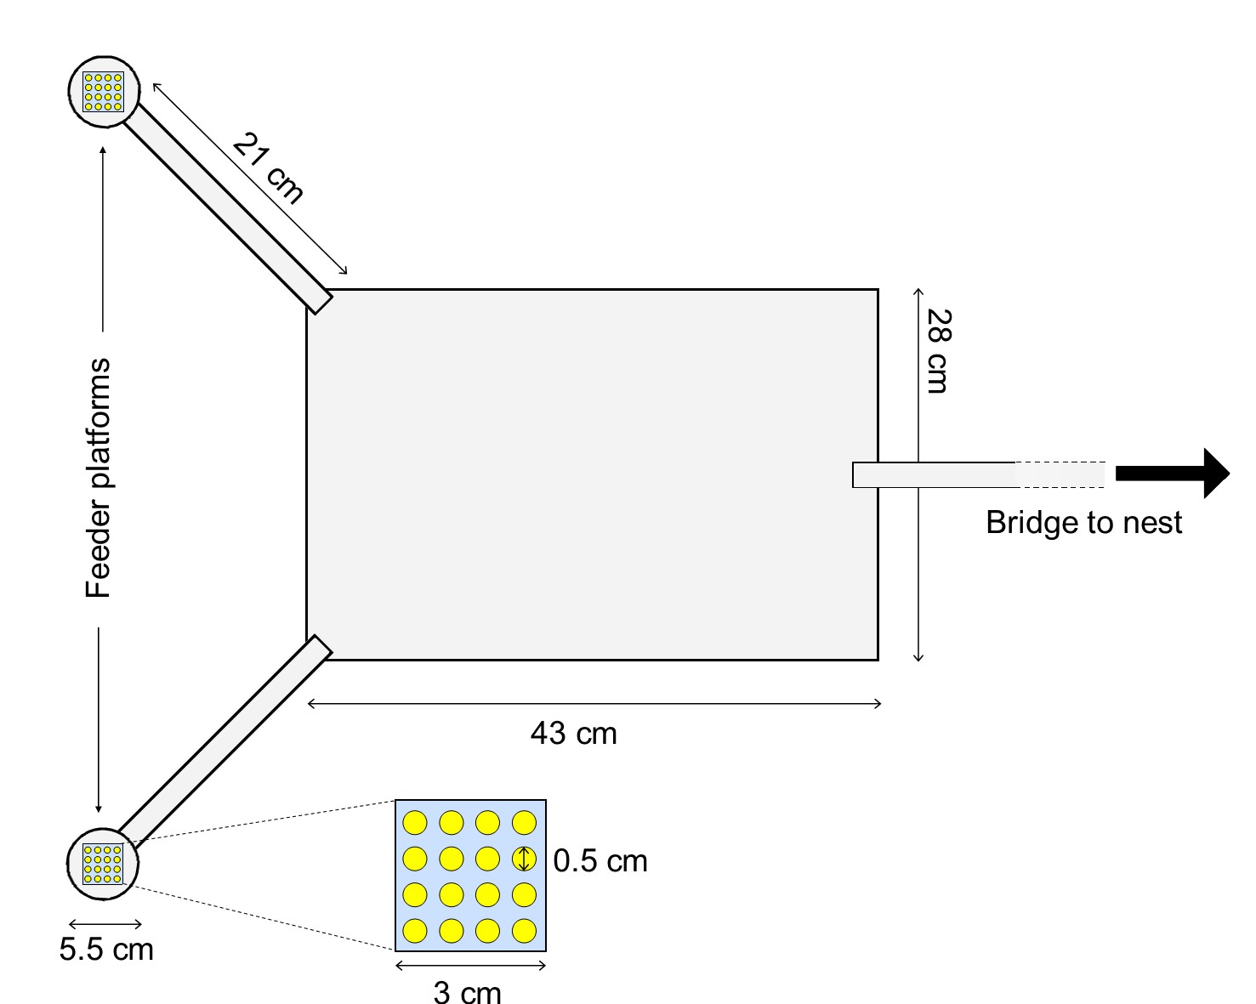
Fig. 1) Experimental setup. For 30 minutes, 0.55 M sucrose solution was provided on one feeding platform (fixed feeder), whereas on the variable feeder the quality of the sucrose solution was alternating between 0.1 M and 1 M. Alternation was implemented by replacing the drops of sucrose solution present by their reciprocal counterpart every 3 minutes. On positive control trials, both feeders offered a fixed quality sucrose solution: one 1 M and one 0.1 M

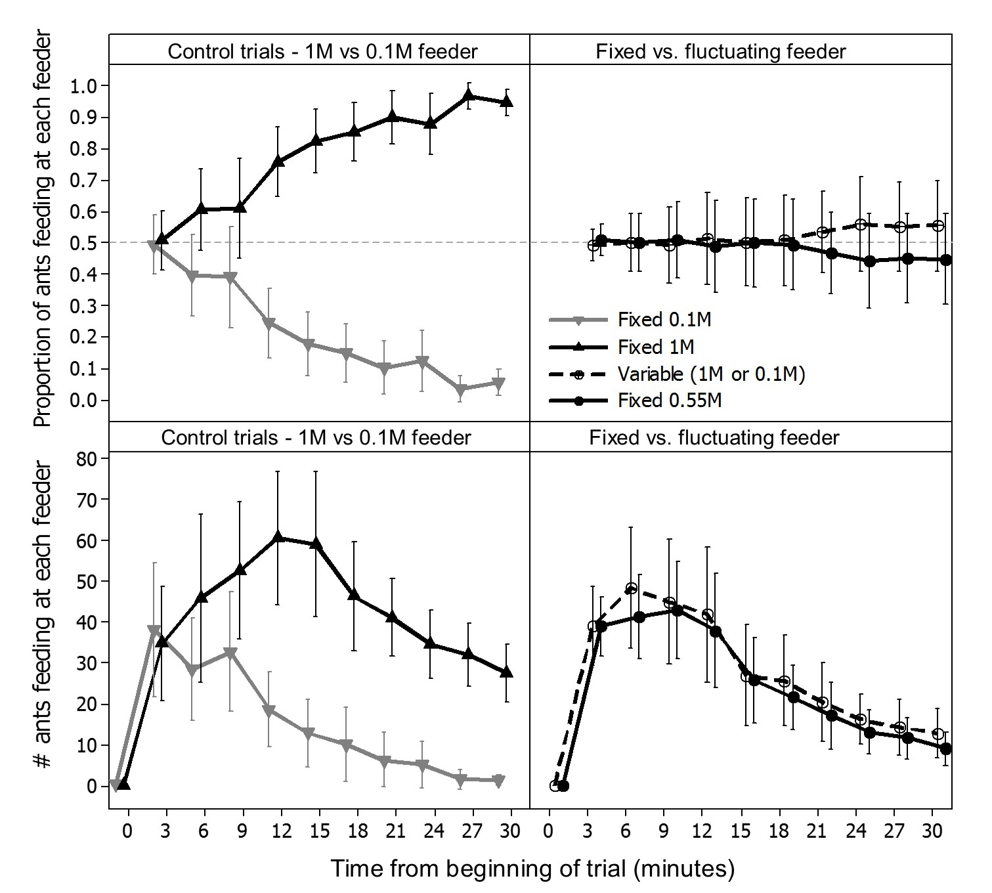
Fig. 2) Collective decisions in the control and risk-preference experiments. In positive control trials (A & C) colonies successfully made a collective decision for the higher quality feeder. In the risk preference trials (B & D) no strong preferences can be seen. Top panels show the proportion of ants feeding at each feeder, bottom panels show the absolute number of ants feeding at each feeder. Symbols are means, whiskers are 95% confidence intervals for the mean.
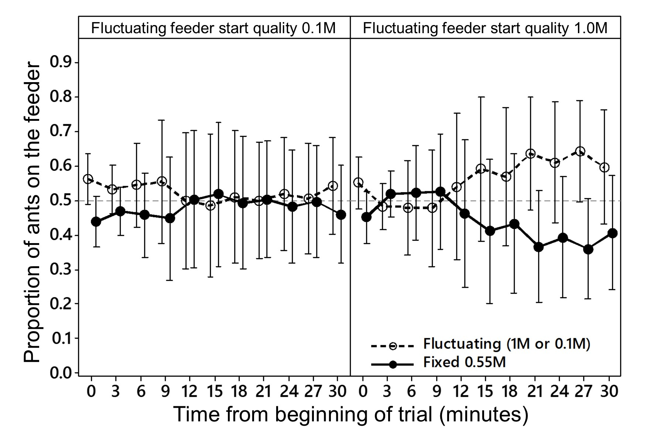
Fig. 3) Collective decisions in the risk-preference experiments, according to the initial quality of the variable feeder. A & C) Variable feeder initially offered a low reward. B & D) Variable feeder initially offered high reward. A & B show the proportion of ants feeding at each feeder, C & D show the absolute number of ants feeding at each feeder. Symbols are means, whiskers are 95% confidence intervals for the mean.

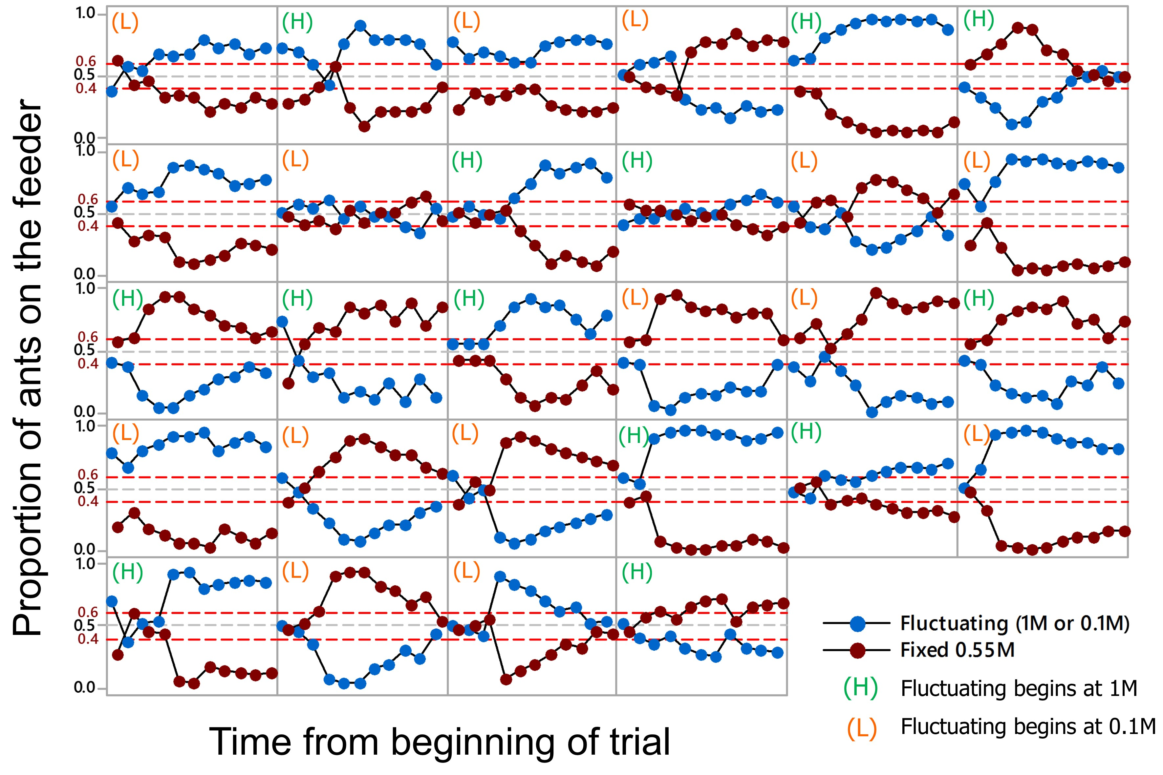
Fig. A1) proportion of ants on the fluctuating feeder for each test trial. Note that in all but two trials from one colony (second row, columns 2 and 4), colonies make a clear collective decision. However, both feeders are decided for equally often.

